PASTOR’S PEN
The Messenger
First United Methodist Church
1339 W. 400 N., Marriott-Slaterville UT 84404
Web: fumcogdenut.org ~ Email: ogdenfumc@aol.com

“Then the Lord answered me and said: ‘Write the vision; make it plain on tablets, so that a runner may read it. For there is still a vision for the appointed time . . . the righteous live by their faith” (Habakkuk 2:2-4).
The prophet Habakkuk wrote at a time when the Babylonians were conquering Jerusalem. Even with the horrible events that were happening to him and his fellow citizens, Habakkuk was able to see that God had a positive and powerful message for him to proclaim.
God instructed Habakkuk: “Write the vision plainly so even a runner can read it.” Some biblical scholars think this means that Habakkuk was supposed to write the vision so clearly on a big sign that even someone who was running by very fast could make sense of it. Another, probably more accurate, interpretation is that runners carried messages from one authority to another. But God didn’t intend that only the learned and wealthy recipient who lived in a palace should be able to hear and understand God’s message. Even the lowly runner should be able to make sense of it and benefit from what God was saying.
God wanted all the people to know that those who were righteous and just could live by their faith. If they would trust in God, they would survive and things would be OK. In the final verses of his prophecy, Habakkuk put it like this: “Though the fig tree doesn’t blossom and no fruit is on the vines . . . yet I will rejoice in the Lord; I will exult in the God of my salvation. God, the Lord, is my strength; he . . . makes me walk upon the heights.”
In worship October 6-November 3, we will be exploring the theme of “20/20 Vision.” That vision will give us 20/20 hindsight to our church’s founding in 1870, give us a clear picture of our present ministries, and enable us to see the future of our congregation. As we see with 20/20 vision, we will experience God’s sustenance and direction. We will see God’s vision in which the righteous live by faith.
Seeing with faith,
Rev. Kim

FALL YARD CLEAN-UP
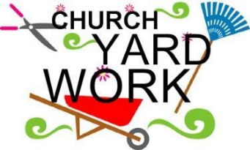
The Trustees will be gathering on Saturday, October 5th at 9am to do some yard work. They need lots of help to get our grounds looking great in time for the Veterans Tribute Run/Chili Cook-Off and the Craft Bazaar. Please join the Trustees and bring gloves, tools, (clippers, string trimmers, rakes, pruners, loppers, etc.) and lots of energy, and let’s get this done! If you need more information, contact Mitch Boren at (801) 430-4367.

OCTOBER IS STEWARDSHIP DRIVE MONTH
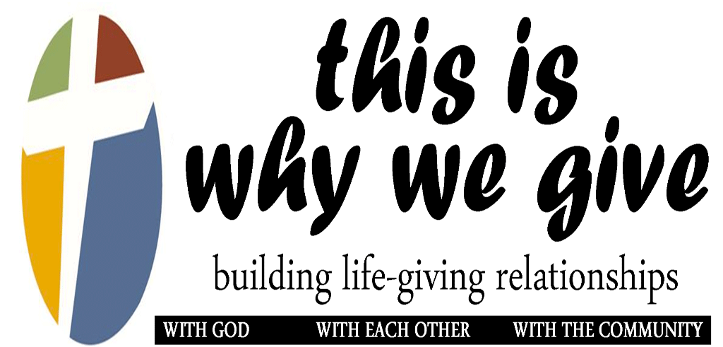

Throughout the month of October, we will hear from various lay speakers about their vision of giving in and through First United Methodist Church. They will share from their experience about what led them to a life of generosity, what keeps them engaged in faith, and what their hopes and dreams are for our church in the year 2020.
In mid-to-late October, you will receive a letter in the mail with a pledge card. We ask that you will pray carefully about what God is leading you to contribute to the ministries of First UMC in the year 2020. Please then complete your pledge card and return it to church on (or before) Sunday, November 3.

STEWARDSHIP SERMON SERIES: “20/20 VISION
Oct. 6: “The Vision of a Faithful Past”
Oct. 13: “The Vision of a Strong Present”
Oct. 20: “The Vision of Future Possibilities”
Oct. 27: “The Vision of Dedication to God”
(Rev. Olga Hard, Guest Preacher)
Nov. 3: “The Vision of Generosity”

FUMC’S VISION STATEMENT
First United Methodist Church
will meet spiritual needs
by developing relationships
with Christ, community, and the world.

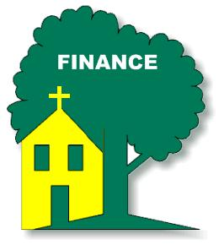
CHURCH FINANCES 101
Here are some important terms for understanding the church’s finances.
- General Operating Fund: This is the basic and primary fund of the church through which we pay for things like worship, Christian education, youth ministry, and mission around the world. This is the fund through which we pay for utilities, salaries, mortgage, and photocopies. This fund is foundational to the ministry of our congregation.
- Pledge: We ask members and supporters of our church to make dedicated estimates of their giving for the upcoming calendar year by filling out a pledge card. This enables the church to create a reasonably accurate and attainable budget. If your circumstances change later, you can revise your pledge by contacting our Finance Secretary, Richard Carr.
- Electronic Giving: Since most of us don’t carry around much cash or our checkbooks any more, and since the offering plate isn’t equipped for swiping a credit/debit card, many of us choose to set up electronic giving directly from a bank account in the form of an ACH. There are variations on this, such as giving from your credit card through our website, using your own bank’s bill-paying feature, or sending a direct distribution from your IRA. Electronic giving forms are available in the pews. You can also give by text message.
- Endowment Fund: This is an opportunity to give to the future of the church. When you give a little bit every month, and/or set up planned giving in your estate (for when you pass away), you help our church fund ministries for years to come. Once our FUMC Endowment Fund principle reaches $100,000, then earnings above that amount can be used to benefit our ministries. As of August 31, our Endowment Fund balance was $49,967. Please help us reach the $100,000 goal!
- Designated Funds: FUMC does have a number of designated (secondary) funds that are used for specific projects and ministries. Examples are Youth Mission Trip, Land Expansion, Phase 2 Building, UMCOR, and JENAR. If you would like to give to a designated fund, you can do so at any time by marking your check or giving envelope accordingly. Always make checks payable to FUMC.
- Appreciation: Besides the increasing value of our investments, this is what the leadership and members of First UMC, the community, and the world have for your generosity to God and others through our church! Thank you! You make a positive difference!

VETERANS RUN/CHILI COOK-OFF - OUR 12TH YEAR
The George E. Wahlen Veterans Tribute Run and Chili Cook-off will take place Saturday, October 12th. The committee needs your help in order to make this a successful and memorable event.
Remember, all the proceeds less our costs (e.g. T-shirts, advertising, etc.) will be donated to the George E. Wahlen Veterans Home to support the veterans living there. These funds assist the Veterans Home Activities Director to offer recreation services to the veterans not supported by either federal or state funds. Last year we were able to donate over $11,000 to the George E. Wahlen Veterans Home, which was greatly appreciated by the veteran’s home staff. Our committee is striving to surpass last year’s donation and our volunteers are a very significant part of that success.
We Need Participants
First of all – we need participants! Please sign up to participate in this event and encourage family and friends to do the same. The majority of the money raised for this event comes from registration fees. This is meant to be a family event, so persons of all ages and abilities are encouraged to participate in the actual walk/run. There will be activities taking place during and after the race including a bounce house for younger children (ages 5-10), a trailer for shooting basketballs, and bean bag tosses (courtesy of the United States Army). Our children’s playground will be for use as well. We will also have a special guest, Destate the Eagle, from The Ogden Nature Center. Lastly, the Chili Cook-Off means there will be lots of tasty food for all!
We Need Volunteers
Secondly - we need volunteers from our congregation to actually work before, during, and after the run/walk and chili cook-off. As in previous years, this volunteer effort will only require 2-3 hours of time on the day of the event, so technically you can walk/run the event and then volunteer before or after too. We are expecting a large turnout for the race/walk and the chili cook-off and we will need lots of volunteers. This has become a community event and participants will be visiting FUMC and using our facilities. So this is our chance to meet and greet with the community.
We Need Blood Donors
Thirdly - the Red Cross will be inside the First United Methodist Church on Saturday October 12th from 10:00 am to 2:15 pm in conjunction with the Veterans Tribute Run. To schedule a time to donate blood, sign up at the Veterans Run table in the Narthex. We are all aware of the disasters due to hurricanes/flooding, fires and earthquakes which have devastated many people worldwide. Additionally, there are many people who require blood donations to survive illness/disease, surgery, and tragedy in your local community. This is an opportunity to support others with a life-saving gift.
If you would like more information, please ask Scott Warren, or any of the committee members – Marty Smith, Larry Meckley, Ray Christian, or Vern Blair - about the vets run and chili cook-off. Your help in volunteering is greatly appreciated.

OCTOBER MISSION EMPHASIS
This month, our Mission Emphasis is our denominational Mission Shares, which is our congregation’s first missional priority every year. Mission Shares goes toward our cooperative ministries with other United Methodist churches. By pooling our resources, we are able to carry out our United Methodist mission of “making disciples of Jesus Christ for the transformation of the world” right here in the Utah-Western Colorado District, in the Mountain Sky Conference, in the Western Jurisdiction, and around the globe.
At the general church level, our contributions go into several funds: World Service (mission and ministry programs), Ministerial Education (seminaries and clergy continuing education), Episcopal (supporting our bishops), Black College (the UM historically-black colleges), General Administration (finance, trustees, legal, and general conference), Africa University (UM training), and Interdenominational Cooperation (with other churches).
Our annual budget for Mission Shares is approximately $25,000. Your loose change and designated gifts in the offering plate (or Mission Box) in October will help us reach that goal.
CHURCH CONFERENCE DATE SET
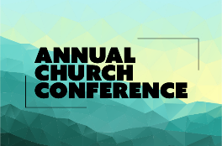
Our yearly Church Conference date has been set. District Superintendent Marv Vose will meet with us at FUMC on Sunday, November 24, at 11:30 a.m. All annual written reports from church leaders will be due to the office no later than Nov. 15.

BOOK TALK
The Book Talk book for the month of October is The Great Alone by Kristin Hannah. Join us on Monday, October 14th at 6:30 p.m. at the home of Cheryl Thompson for our discussion. Contact Cheryl at 801-389-9864 for more information.

UNITED METHODIST WOMEN NEWS

The UMW have been very busy lately. Therefore, with the Craft Bazaar, there will be no UMW meeting in October.

CHURCH CRAFT BAZAAR
Calling all crafters, bakers, and artisans! This year the craft bazaar will take place on October 25th and 26th, which is almost upon us. We hope you have been planning your creations to contribute; your skills and talent will enable us to be successful as in years past. If you can bake, sew, craft, weave, knit, crochet, whittle, paint, weld or express yourself creatively in any way - we need you to create items for our bazaar! Even if you are not creative and cannot contribute items toward the bazaar, you are needed as a volunteer at the bazaar. This bazaar could not take place without the multitudes of volunteers who set-up for the event and then assist in running the event. We hope we can count on you to be part of the team that works together to make this such a blessing to so many others! Sign-up sheets coming soon. Lastly, please consider attending the bazaar and doing some early Christmas shopping. There will be many hand-made, one-of-a-kind items to gift yourself or someone you know. Come hungry and grab a bite to eat while you’re here. For questions, contact Colleen Blair at 801-392-5255.
NOMINATIONS COMMITTEE WILL MEET
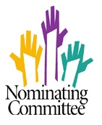
The FUMC Nominations Committee will begin meeting in October to recruit church leaders for 2020. Our ministries don’t happen by accident. They happen because faithful people have gathered, prayed, thought, discussed, and planned. If someone from Nominations calls you, please consider prayerfully how you might best serve God through First UMC. If there is something you particularly feel led by God to do, please don’t hesitate to share that with one of these Nominating Committee members: Joan Wade, Chris Hicks, Nora Hughes, Paul Kriekard, Peggy Davis, Walter Branch, Karen Lee, Karen Trenholm, Linda Gates, Kerry Conrad and Rev. Kim. Meeting times will be October 2, 9, and 15 at 9:30 am.

COMMUNITY GARDEN and PROJECT S.W.I.F.T.S.
Many thanks for everyone's support of our Community Garden this season. It was a great year with all the good workers providing countless hours of time to make it happen, healthy food for the Lantern House guests and ourselves, generous monetary donations and lots of camaraderie!
Come out and get your Halloween pumpkins from the Garden at the Vets Tribute Run. All proceeds go the Activity Fund at the home.
While the garden work is winding down, Project S.W.I.F.T.S: Sustainable Water Initiative: Food to Share is ramping up!
We hosted a successful fundraising Water Smart Dinner on September 27th. Due to the fact that this article is being composed before the dinner is held, details are forthcoming. We have two promising grants that we are applying for to fund the infrastructure work to make the secondary pressurized drip irrigation system a reality. Plans are underway for possibly getting the system installed next spring! Stay tuned!!
BEEKEEPING MINISTRY
We beekeepers have been as busy as our bees getting ready for our annual Honey Sale on Saturday, October 26 from 9:00 AM to 4:00 PM in conjunction with the Craft Bazaar. We will only have our booth on Saturday, no Friday sales.
Come out early and get all you favorite products plus a few new ones (Cherry Dessert Sauce, Jalapeno Jam) and the ever popular Honey Peach Salsa! Thank you for your support!
Questions? Kristen Bell, Queen Bee, bellf4m@comcast.net

PROGRESS ON SR. LIVING COMMUNITY
Rev. Kim continues to dream about developing a faith-based senior living community. Over the past month or so, she has been having conversations with local clergy (Ascension Lutheran and St. Paul Lutheran) and the Church Council of Community UMC. She has also made a positive connection with Presbyterian Homes and Services of Minnesota, which is working on a tiny, first-phase market study for us. October 26-30, Rev. Kim will go to the Leading Age Conference in San Diego, where she will network with many others who are doing this kind of non-profit ministry with seniors.

BUDGET REQUESTS DUE OCTOBER 31
The Finance Committee will soon need to formulate our 2020 budget. Thus, every committee needs to turn in its budget requests no later than October 31. If your committee hasn’t yet worked on this, please ask Gail to prepare a budget worksheet before your next meeting, and plan time for this on your committee’s agenda. As you prepare the budget, remember to consider the vision of FUMC. Ask how we can best meet spiritual needs through your work area. The budgeting process will also need pledges from all those who participate in the ministries of FUMC.
FUMC YOUTH NEWS
Youth Schedule
Oct. 6 Service Project
Oct. 12 Help at Veterans Tribute Fun Run
Oct. 12 80's Dance @ Mtn. Vista UMC
Oct. 20 Bowling
Oct. 27 Cookie Fundraiser
If you have any questions about youth group activities please contact Austin Barron at (801) 814-7757.

CHILDREN’S SUNDAY SCHOOL
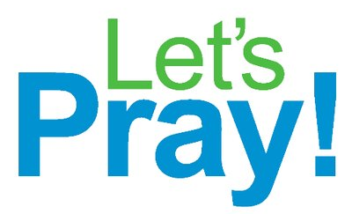
Our children will continue their Sunday School workshop rotation on The Lord’s Prayer until October 13. Thank you to those that have signed up to teach. Watch for ways that the children are learning The Lord’s Prayer and discovering that we can learn to pray in many ways. Check out the hallway bulletin board and the prayer squares. Feel free to add your prayers under the headings “Help Me”, “Thank You”, “Wow!” or “For the World”.
We will start a new unit on October 20 entitled God Chooses Joshua. Children will hear the story of God choosing Joshua as Moses’ successor, discover that God chose Joshua to do God’s work and Joshua chose to serve God, and learn that we can choose to serve God! The Bible verse for this 6-week rotation is “But my family and I will serve the Lord.” (Joshua 24:15) and the anchor point is We choose to serve God. As in the past, we are looking for volunteers to teach the workshops - Games, Mission, Spiritual Practices, Art, Storytelling, Cooking and Science. Watch for a sign-up sheet in early October. Please talk to Brenda if you have any questions.

REFORMATION SUNDAY SERVICE
AND OKTOBERFEST DINNER
St. Paul Lutheran Church has invited our congregation to their Reformation Service and dinner on Sunday, October 27, 2019. Worship Service begins at 4:00pm. Dinner follows at 5:30pm. Come and enjoy! Suggested Donation: $7.00 per person.
3329 Harrison Blvd., Ogden, UT (801) 392-6368
Menu includes: Bratwurst & Sauerkraut, Hot German Potato Salad, Hot Dogs & Macaroni and Cheese + Vegan, Dessert & Beverages.

